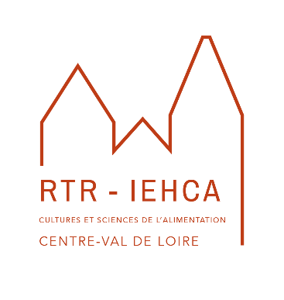
Food Crises
Challenges, Innovations and Sustainable Change

Conference organized by the Institut Européen d’Histoire et des Cultures de l’Alimentation

Tours (France) – 14-16 December 2023

Call for papers

The global COVID-19 pandemic has highlighted distribution issues, the ever-present fear of food shortages, the social significance of restaurants and eating together, booming delivery / take-away sales and greater appreciation of short supply chains. In 2022, the war in Ukraine triggered disruptions to international trade as well as inflationary pressures and the threat of famines in many parts of the world. Challenges of such scale often lead to adaptations and reinforcements of existing trends but also profound and lasting transformations. More generally, from prehistoric times to the present, crises relating to military conflicts, climatic hazards, health challenges, harvest failures, economic decline, environmental change, geopolitical conflicts and many other factors have affected food systems in complex and varying ways, depending on specific constellations, local resilience and the timescales involved. In some cases, the extent of disruption remained limited, in others it proved extreme.
Researchers have long been interested in specific cases, such as the effects of the Black Death in the fourteenth century, subsistence crises of the Ancien Régime, the great famines of the modern world or issues of wartime supply. They have investigated causes (epidemics, natural disasters, policy failures), adaptation strategies (cultivation of alternative crops, rationing, improved sanitary controls, general market regulation) and outcomes (noting variable degrees of success).
The distinctive aim of this conference is to examine the ‘creative’ and ‘constructive’ potential of the relationship, specifically the extent to which crises can trigger innovation and sustainable change within food systems. The latter include modes of production, retail channels, consumption patterns, public health regulations, dietary advice, technological means, government policies and many other aspects. To enhance comparative perspectives, we welcome contributions on all periods, regions and types of crises. Possible topics might include, but are not restricted to:
- Adaptations, modifications and changes of direction at all levels of the food system
- Examples of innovative technologies (apps, big data) and official interventions (health advice risk management and food security measures)
- Emergence of new models of food cultivation, distribution, retail and consumption
- Responses by community / environmental organizations, charitable institutions, philantrophers, NGOs etc
- Assessments of temporary vs lasting transformations
- Food narratives in times of crisis
- Theoretical or conceptual models rethinking elements of the food system
- Factors affecting the severity of impact and/or resilience
- … and many more!
At the same time, the conference will offer an opportunity to (re)assess the impact of the Covid-19 crisis on the food system through a round table discussion involving researchers, policy makers, business representatives and members of the public.

Scientific Committee :
Guido Alfani (Università Bocconi, Milan)
Isabelle Bianquis (Université de Tours)
Emmanuelle Cronier (Université de Picardie-Jules Verne)
Jessica Dijkman (Universiteit Utrecht)
Beat Kümin (University of Warwick)
Pierre Janin (Université Paris 1 Panthéon Sorbonne)
Nicolas Larchet (Université Le Havre Normandie)
Philippe Meyzie (Université Bordeaux Montaigne)
Peter Scholliers (Vrije Universiteit Brussel)
Carmen Soares (Universidade de Coimbra)

The conference will take place at Tours in France from Thursday 14 to Saturday 16 December 2023. We now invite proposals (of max. 3000 characters) for 20-minute presentations (in English or French), which should be sent – together with a biographical note (of max. 2000 characters) – to the following email addresses by 28 February 2023:
emmanuelle.cronier@u-picardie.fr
B.Kumin@warwick.ac.uk
philippe.meyzie@u-bordeaux-montaigne.fr
The IEHCA 2023 conference on ‘Food Crises’ is organized in partnership with the ‘Food’ Global Research Priority of the University of Warwick and co-directed by Emmanuelle Cronier (Université de Picardie-Jules Verne), Beat Kümin (University of Warwick) and Philippe Meyzie (Université Bordeaux Montaigne).

